2023/03/20
何奇偉教師：
中国几乎没有基督教……华人翻译圈耗费心血竭力翻译异端作品、“供养”国内主流教派之需求，精美包装、出版推销，生怕“营养”毒素跟不上

胡牧得牧師：
翻译事工是非常重要的事情，文以载道。大部分人自己本身就是重洗派的传统，只能辨认出自己喜欢的垃圾，还有一些更邪恶的人为了追求市场和经济收入，制作垃圾书籍充斥在中文学界。这些钱财将会成为他们的咒诅。单单只是看教会历史书，我们在预备初译菲利普沙夫的八卷本历史著作的时候，仔细观察中文历史书，可以说翻译过来中文的教会历史书百分九十以上都是来自异端历史观。何等可悲。

劉麗麗姊妹：
反正我走了很多弯路，浪费了许多时间金钱，给许多的假牧师假教会捐了些银子。感谢主，现在终于走在归正的路上。感恩
记得我刚信主的时候在福音影视网上看苏文峰讲解的《基督教世界历史》，记得最清楚的是他讲《多特大会》的时候，说抗辩派（阿米念派）和所谓的“郁金香五要点”都是正确的，关键在于你愿意相信哪一方。当时我也不太明白，只觉得他好敬虔，因为他读经文的时候感动到哽咽落泪。

胡牧得牧師：
翻译事工是非常重要的事情，文以载道。大部分人自己本身就是重洗派的传统，只能辨认出自己喜欢的垃圾，还有一些更邪恶的人为了追求市场和经济收入，制作垃圾书籍充斥在中文学界。这些钱财将会成为他们的咒诅。单单只是看教会历史书，我们在预备初译菲利普沙夫的八卷本历史著作的时候，仔细观察中文历史书，可以说翻译过来中文的教会历史书百分九十以上都是来自异端历史观。何等可悲。
甚至一些自称自己也是改革宗的机构，大量推送的也不过就是浸派背景司布真钟马田之流的劣质作品。非常奇怪为什么不翻译十六世纪十七世纪的大量属灵遗产宝藏？例如我们在制作过程中的威廉珀金斯，威廉埃姆斯的书，乌尔西努博士对海德堡教理问答注解的作品。这些作品都是经典中经典著作，而且非常简洁易懂，真的太好了。
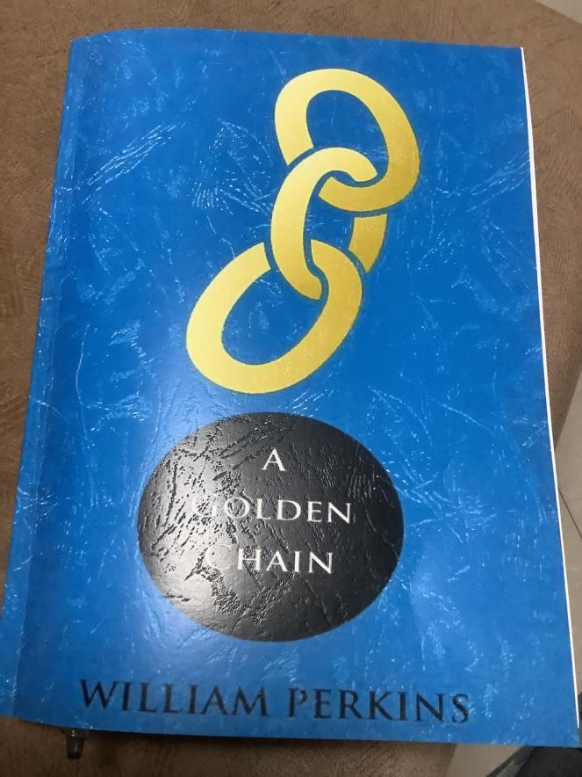
我们也快搞好了。内部使用，以中英文双语对照的形式呈现出来。
我们这么做的原因就是把翻译当成一种开元性和开放式的，让懂英文又有神学功底的人可以继续进行修订。同时也可以帮助更多的人学习和了解一下英文，大家不要以自己不懂为荣，要持续努力，这样期待大家在教义精准度上可以接受到原作者的最原版的用词和阐述。
这种情况就显明讲者是无知的人，他不但在教会历史上是糊涂蛋，而且非常肯定的是讲者是阿米念主义支持者。不过确实好像很多人都是听这种课程来学习历史的。

https://www.facebook.com/reftoons/posts/the-golden-chain-of-redemptioncheck-out-chosen-by-god-by-rc-sproul-httpsamznto2r/333662220721425/
http://stretchtheology.com/why-its-worth-reading-william-perkins-a-golden-chain-1590/
https://redeeminggod.com/romans-8_28-30-golden-chain-of-salvation/

Hand-typed, formatted, corrected, modernized, and annotated by William H. Gross www.onthewing.org March 2019.

William Perkins’ “A Golden Chain” is a guide to Puritan theology - a superb rendering of Reformed doctrine as interpreted by the Puritans. His analysis of the doctrine of salvation is exemplary, especially in his application of the work of Christ to the elect. Perkins affirms that faith is the consequence of God’s effectual call rather than of sinful man’s “free will.”

"Contemporary scholars have called Perkins 'the principal architect of Elizabethan Puritanism,' 'the Puritan theologian of Tudor times,' 'the most important Puritan writer,' 'the prince of Puritan theologians,' 'the ideal Puritan clergyman of the quietist years,' 'the most famous of all Puritan divines,' and have classed him with Calvin and Beza as third in 'the trinity of the orthodox.' He was the first theologian to be more widely published in England than Calvin and the first English Protestant theologian to have a major impact in the British isles, on the continent, and in North America. Little wonder that Puritan scholars marvel that Perkins's rare works remain largely unavailable until now." - Dr. Joel Beeke

To the Christian Reader

Christian Reader, there are at this day four separate opinions of the order of God’s Predestination. The first is of the old and new Pelagians, who place the cause of God’s Predestination in man. They hold that God ordained men either to life or death, as He foresaw that, by their natural Free-will, they would either reject or receive the grace He offered. The second, some of whom are termed Lutherans, teach that God — foreseeing how all mankind was imprisoned under unbelief, and would therefore reject grace offered — purposed to choose some to salvation out of his mercy, without any respect to their faith or good works, and to reject the rest. He was moved to do this because he eternally foresaw that they would reject His grace, offered to them in the gospel. The third, Semi-Pelagian Papists, ascribe God’s predestination partly to mercy, and partly to men’s foreseen preparations and meritorious works. The fourth, are those who teach that the cause of the execution of God’s predestination in those who are saved, is his mercy in Christ; and in those who perish, it is the fall and corruption of man — yet this is done in such a way that the decree and eternal counsel of God concerning them both, has no cause besides His will and pleasure.

Of these four opinions, I labor to impugn the three former ones as erroneous, and to maintain the last as being truth, which will bear weight in the balance of the Sanctuary.

Here I boldly offer for your godly consideration, a further discourse on this. In reading it, do not regard so much the thing itself, penned very slenderly, as my intent and affection. I desire, among the rest, to cast my mite into the treasury of the Church of England; and for lack of gold, pearl, and precious stone, to bring a Ram’s skin or two, and a little Goat’s hair, to the building of the Lord’s tabernacle (Exo 35:23).

The Father of our Lord Jesus Christ grant that, according to the riches of His glory, you may be strengthened by His Spirit in the inner man, that Christ may dwell in your heart by faith. This is to the end that, being rooted and grounded in love, you may be able to comprehend with all Saints, what is the breadth, and length, and height of it; and to know the love of Christ which surpasses knowledge, that you may be filled with all fullness of God. Amen.
Farewell, July 23, the year of the last patience of Saints, 1592.
Yours in Christ Jesus,
W. P.

-----

Notes Regarding this version

The text is taken from the typeset version of this book, printed in English in 1600. What Perkins himself wrote had not yet been edited or translated. These are his own words as he recorded them, and as John Legate typeset them.

Perkins’ language is straightforward, and a delight to read. It contains a series of doctrinal statements, often without much explanation. He presents these truths, topically arranged, citing specific verses from which they were drawn. It reads like an annotated confession, or a systematic theology, but in a style that’s more accessible than Ames’ Marrow (1629), and published long before the Westminster Assembly (1643). Perkins allows the word of God to speak for itself, which is a welcome approach, and wonderful in its simplicity.

Because this book was written prior to the King James Version of 1611, his wording provides the biblical text of his day, generally from the Geneva Bible. That wording is retained in this edition, rather than substituting a modern translation for it. But, as with the rest of the text, it has been modernized for readability (thee, thou, -eth, -est, etc., have been replaced with modern terms, spelling, and syntax). Such changes have been kept to a minimum. What you’ll read are his words in a current voice. Book, chapter, and verse numbers have been matched to our modern scheme for easier reference. Many of the biblical references were either wrong, or misread by Legate — those have been corrected. Added references are superscripted, and supporting Scriptures that were not in the original text are footnoted. I confess that I’ve added commentary in some of the notes (these are marked WHG). They offer a further explanation for young believers.

Where the words were dated or unusual, either a substitution was made, its meaning footnoted, or a [bracket] with an alternate word has been included for clarity. To avoid ambiguity, some pronouns have been made explicit; other words are capitalized — for example, the Persons of the Godhead (He, Him, and Holy Ghost). Small caps, boldface, dashes, and other formatting was used to aid in organizing the topics. Verses, sub-headers, and key words were italicized in the original. Hopefully other formatting (indenting, paragraph numbering, etc.), will make the organization more apparent, even if it is inconsistent at times.

The source text (a scanned image of the original book) is available at the link provided at the top of this page. Page numbers are included intra-text in this modernized edition, to help you find the original wording, and for use in citations. The scanned book jumps from page 27 to page 34, with no loss of text between; apparently the pages were mis-numbered in the 1600 edition.

I’ve included a biographical sketch to allow the character of the man to inform his labors, and to explain his influence. He was only forty-four when he was called to eternity with Christ.
William H. Gross
March 2019

P.S. — There is a popular chart of Salvation and Damnation inspired by Perkins’ Golden Chain, but it’s not in this edition of the book. Nonetheless, Tim Challies’ website has such a useful chart here:

Perkins included a few “tables,” but they were smaller and simpler. They may be found in chapters 1, 33, 34, 37, 50, and 54. These are listed in the Table of Contents. They have graphics which will not display correctly in epub formats. Chapters 50 and 54 are the most challenging to read, because Perkins includes numerous objections and answers. That can be tedious (hence the tables), but it’s also helpful.

----

TABLE OF CONTENTS
Biographical Sketch:
To the Christian Reader
Theology Chart
Chapter 1. Of the Body of Scripture and Theology
Chapter 2. Of God, and the nature of God.
Chapter 3. Of the Life of God.
Chapter 4. Of God’s glory, and blessedness.
Chapter 5. Concerning the Persons of the Godhead.
Chapter 6. Of God’s works, and his decree.
Chapter 7. Of Predestination and Creation.
Chapter 8. Of Angels.
Chapter 9. Of Man, and the Estate Of Innocence.
Chapter 10. Of sin, and the fall of Angels.
Chapter 11. Of Man’s fall and disobedience.
Chapter 12. Of Original Sin.
Chapter 13. Of actual sin.
Chapter 14. Of the punishment of sin.
Chapter 15. Of Election, and of Jesus Christ the foundation of it.
Chapter 16. Of the Union of the Two Natures in Christ.
Chapter 17. Of the Distinction of both Natures.
Chapter 18. Of Christ’s Nativity and Office.
Chapter 19. Concerning the Outward Means of executing the decree of election, and of the Decalogue.
Chapter 20. Of the First Commandment.
Chapter 21. Of the Second Commandment.
Chapter 22. Of the Third Commandment.
Chapter 23. Of the Fourth Commandment.
Chapter 24. Of the Fifth Commandment.
Chapter 25. Of the Sixth Commandment.
Chapter 26. Of the Seventh Commandment.
Chapter 27. Of the Eighth Commandment.
Chapter 28. Of the Ninth Commandment.
Chapter 29. Of the Tenth Commandment.
Chapter 30. Of the Use of the Law.
Chapter 31. Of the Covenant of Grace.
Chapter 32. Of the Sacraments.
Chapter 33. Of Baptism.
The Sacramental Union of the Parts of Baptism
Chapter 34. Of the Lord’s Supper.
The Sacramental Relation in the Lord’s Supper
Chapter 35. Of the Degrees of Executing God’s Decree of Election.
Chapter 36. The 1st Degree of the Declaration of God’s Love: Effectual Calling.
Chapter 37. The 2nd Degree of the Declaration of God’s Love: Justification.
Imputation of Christ’s righteousness
Chapter 38. The 3rd Degree of the Declaration of God’s Love: Sanctification
Chapter 39. Of Repentance and the Fruits of it.
Chapter 40. Of Christian Warfare.
Chapter 41. Of the 1st Assault: on Calling.
Chapter 42. Of the 2nd Assault: on Faith.
Chapter 43. Of the 3rd Assault: on Sanctification.
Chapter 44. Of the Patient Bearing of the Cross.
Chapter 45. Of Calling upon God.
Chapter 46. Of Christian Apology and Martyrdom.
Chapter 47. Of Edification, and Alms among the Faithful.
Chapter 48. The 4th Degree of the Declaration of God’s love: Glorification.
Chapter 49. Of the estate of the Elect, at the Last Day of Judgment.
Chapter 50. Of the Estate of the Elect After Judgment.
Chapter 51. Concerning the Order of the Causes of Salvation according to the doctrine of the Church of Rome.
A View of the Distribution of the causes of Salvation & Damnation as the Church of Rome would have it.
Chapter 52. Concerning the Decree of Reprobation.
Chapter 53. Concerning the Execution of the Decree of Reprobation.
Chapter 54. Concerning a Newly Devised Doctrine of Predestination, taught by some new and late Divines.
A Frame of the Doctrine of Predestination
Chapter 55. Of the State and Condition of the Reprobates When They are Dead.
Chapter 56. Of the Condemnation of the Reprobates at the Last Judgment.
Chapter 57. Of the Estate of the Reprobates in Hell.
Chapter 58. Of the Application of Predestination.
https://www.monergism.com/golden-chain-ebook

